GDPR User Guide

Grainger
GDPR Anonymization

Version 1.0
July 08, 2024

Contents
1.1 Overview 3
1.2 Document Purpose 3
1.3 Intended Audience 3
1.4 Identifying records for Anonymization 4
1.5 How anonymization works 4
1.6 How to receive error emails 5
1.7 How to create test data 5
1.8 Batch class running user setup 5
1.9 How to include the field to be anonymized 6
1.10 Backup and Restore Data 6

Introduction

Overview
Grainger plc has recently had some audit findings from PwC highlighting the potential
non-compliance with GDPR regulations relating to personally identifiable information
(PII) for individuals who were either unsuccessful prospective tenants or are no longer
active tenants. This data is held in the Grainger plc Salesforce org on Lead and Contact records respectively.

In order to remedy this, Open Box is proposing to develop an automated process
within Salesforce that will anonymise the relevant Lead and Contact records, thereby
removing the PII data while retaining the records themselves for use in reporting that
isn’t reliant on valid PII data (historical trends, volumes, conversion rates etc.)

Document Purpose
- Provide clarification on the implemented solution and steps for testing for end users and Grainger Salesforce administrators
- Use configurable selection criteria to identify all Lead and Contact
records for which PII data must be anonymised (e.g. all Leads
created more than 360 days ago that were not successfully
converted).
- Create Fieldsets (or custom metadata types) to hold of all fields
which hold PII data on the Lead and Contact objects respectively.

- For each identified record, update each PII-designated field (as per
ii above) with an anonymised value. The anonymised value will be
unrelated to the original value of the field (i.e. it will be truly
anonymous rather than pseudo-anonymous).
- For each identified record, delete the field audit history records that
may contain PII data (e.g. field audit history records showing change
of email address)

Intended Audience
The document is intended for the following:

- Project Managers
- Testing end users
- Internal Salesforce administrators
- Quality Assurance testers

Identifying records for Anonymization
Leads:
- A Lead has a created date more than 1 year ago
- Lead is not converted
- Lead has not opted in after the communication email was sent
- Communication Opt-In In Date is not 365 or more days prior to today

Then GDPR Anonymization Date is set to Today + 1 day (testing only) as it is needed for Opt-in Communication window

Contacts / Person accounts:

- If a record is created more than 1 year ago AND
- Does not have a contact role in a Closed Won opportunity (active, inactive) AND
- Does not have a contact role in an open opportunity created less than 365 days ago
- (active and inactive) AND
- Has NOT opted in after communication email was sent
- Then GDPR Anonymization Date should be set to Today 1 day (testing only) as it is needed for Opt-In in Communication window
- If a Record has opted in (communication Opt-In in date) Opt-In in is valid for another year from Opt-In In date: PII data will not be anonymised, values remain intact

How anonymization works
Given that the GDPR Anonymisation Date on Lead/Contact/Person Account is less than today, the following will happen
- ‘GDPR Anonymization Date’ field will get date stamped with (today’s date + Opt-In In period)
- Marketing cloud implementation will send out the Opt-In email
- Data will be anonymized with anonymized values if not opted in, as per User story: https://graingerplc.atlassian.net/browse/GA-3 e.g.
- dates = 01/01/1900
- email = *@anonymized.com.invalid
- names = Zb5Ks1xFGFZ94waM6TSY 52Jt44Rctp9E3tW8CJiz

* Names will be assigned random unique text strings to avoid duplicate values

- GDPR Anonymized (checkbox) will be set to ‘TRUE’ to indicate record has been anonymisd

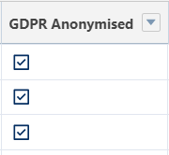

- Deletion of record Field Audit History for PII fields

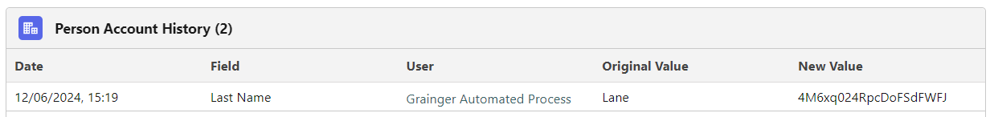

Note: The Salesforce admin can update the configuration as described below so that only one PII field on Lead/Contact/Person Account is anonymized on a given day. Towards the end of UAT testing round, data can be restored and with updated configuration all fields can be anonymized in one go as trial run to match the production setup.

How to receive error emails
There is a custom metadata setting called "GDPR_Anonymization_Batch_Configuration"
Add a comma-separated list of email addresses to receive error emails in case there are errors running the GDPR anonymization batch process

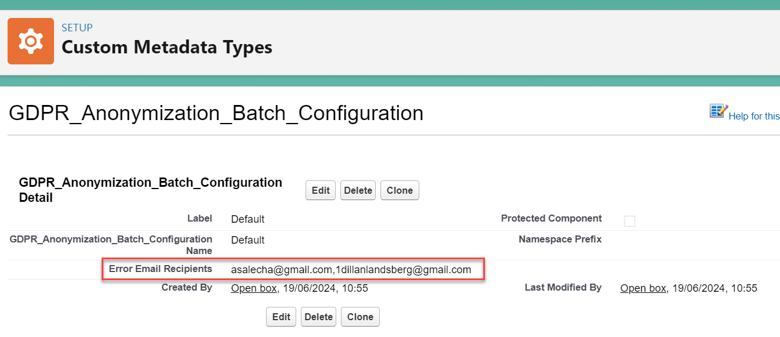

How to create test data
The User creating the test data should have following permission set assigned: GDPR_Audit_Fields_Permissions
The above permission set contains following permission contained:
Set Audit Fields upon Record Creation
More details here - Enable the 'Create Audit Fields' permission

Batch class running user setup

The GDPR Anonymization batch process is run as user - "Grainger Automated Process"
This user has the following permission set assigned to run the batch anonymization process - GDPR Anonymization Batch
The user validation rules are turned off as shown in the screenshot below:

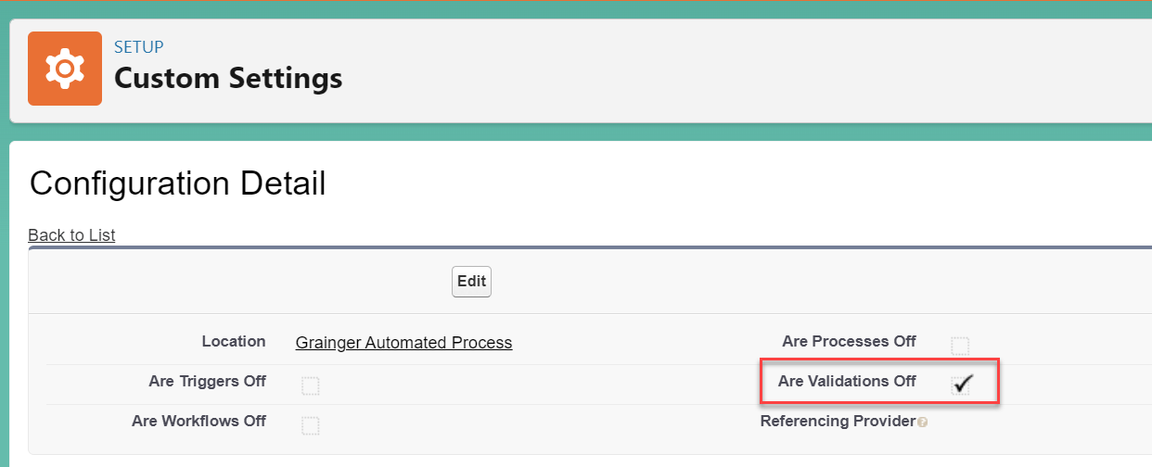

How to include the field to be anonymized

Each object, Lead, Contact, and Person Account has a field set defined named "GDPR_PII_Fields"
The fields added to field Set via drag and drop are anonymized

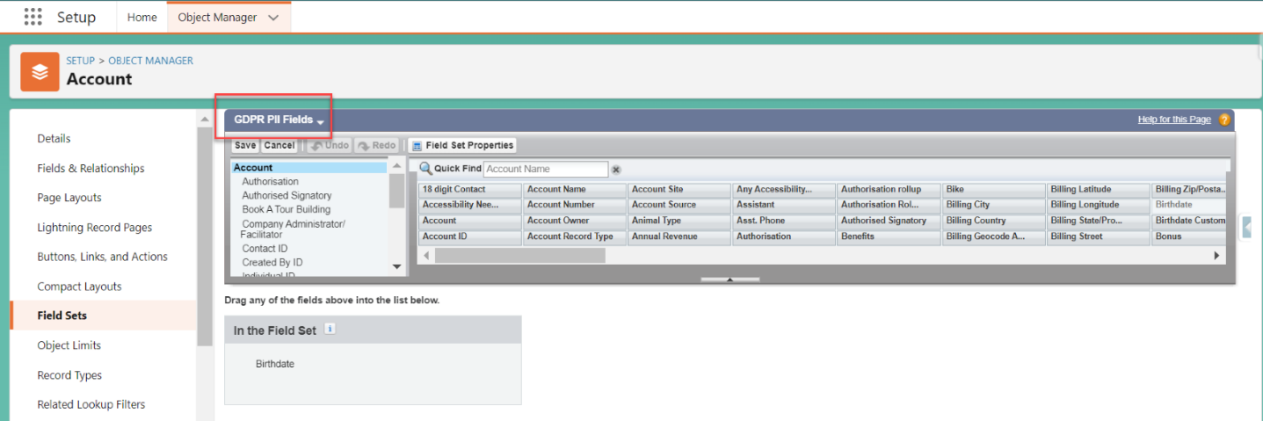

Backup and Restore Data

Restore data from backup contained in following SharePoint folder using data loader
https://graingerplc.sharepoint.com/sites/GDPRAnonymization/Shared%20Documents/Forms/AllItems.aspx

